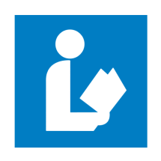
Dunklin County Library E-Books (Read in browser)

- Go to the library website at dunklin-co.lib.mo.us

- Click on the link labeled eBook application.

- Complete application and email directly to library by clicking the email button, or print and take to your librarian. Within 10 days you will receive your username and password for eBooks access.

NEXT

- Once you have received your username and password. Go to the library website at dunklin-co.lib.mo.us for a shortcut to Missouri Libraries 2 go, or enter www.molib2go.org in your web browser.

- Click on the green box: Missouri Libraries 2 go.

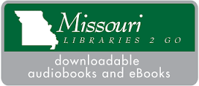EXAMPLE
- Then click on Sign In. It will be located in the far right corner.

- Enter our library name: Dunklin County Library along with your username and password.
- To select a book click on menu and choose a collection of books.

- Click on the book you would like to choose, this will give you the option of placing a hold, (on reserve with notification when available), or borrow.

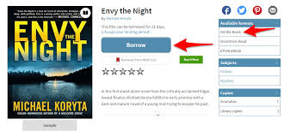 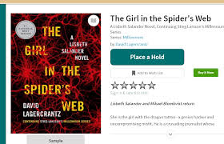Examples

- To Read the ebook in your browser you only have to click the Read (In your browser) button. This will open the ebook in you default browser. You have 14 days to finish reading the book.
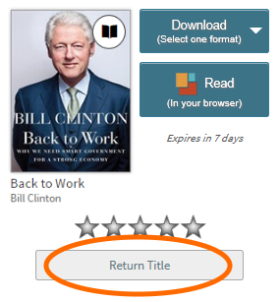Examples

- When finished with book, make sure you return the title as soon as possible to make it available to other library borrowers.

