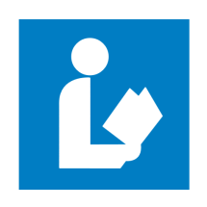
Dunklin County Library E-Books (Kindle)

- Go to the library website at dunklin-co.lib.mo.us

- Click on the link labeled eBook application.

- Complete application and email directly to library by clicking the email button, or print and take to your librarian. Within 10 days you will receive your username and password for eBooks access.

NEXT

- Once you have received your username and password. Go to the library website at dunklin-co.lib.mo.us for a shortcut to Missouri Libraries 2 go, or enter www.molib2go.org in your web browser.

- Click on the green box: Missouri Libraries 2 go.

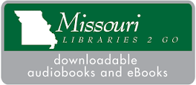EXAMPLE
- Then click on Sign In. It will be located in the far right corner.

- Enter our library name: Dunklin County Library along with your username and password.
- To select a book click on menu and choose a collection of books.

- Click on the book you would like to choose, this will give you the option of placing a hold, (on reserve with notification when available), or borrow.

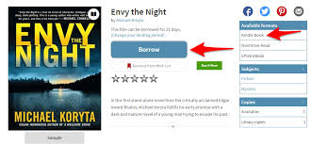 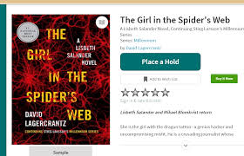Examples

- If you click borrow it will go to check out which gives you the option to read in your browser or download. In download you will select the format of the book either Kindle or epub ebook.
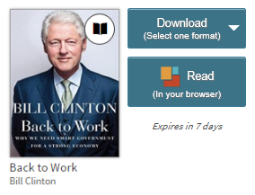Examples
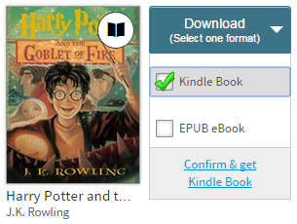Example

- If you select a download of Kindle you must next click on confirm and get book. Then you will be redirected to the amazon website where you will log in to your account. Then you will simply download the book to your selected kindle device by clicking the get library book on the far right side of the screen.

- When finished with book, make sure you return the title as soon as possible to make it available to other library borrowers.

